THE BACKGROUND AND INFLUENCE OF NATURALISM
Pietists emphasized Christian devotion and diligence as paths to the good life; Enlightenment thinkers focused on reason and clear thinking as the sensible way to happiness. Rousseau and his followers were intrigued by a third and more elusive ideal: naturalism. Rousseau, in his A Discourse on Inequality, an account of the historical development of the human race, distinguished between “natural man” (man as formed by nature) and “social man” (man as shaped by society). He argued that good education should develop the nature of man. Yet Rousseau found that mankind has not one nature but several: man originally lived in a “pure state of nature” but was altered by changes beyond control and took on a different nature; this nature, in turn, was changed as man became social. The creation of the arts and sciences caused man to become “less pure,” more artificial, and egoistic, and man’s egoistic nature prevents him from regaining the simplicity of original human nature. Rousseau is pessimistic, almost fatalistic, about changing the nature of modern man.

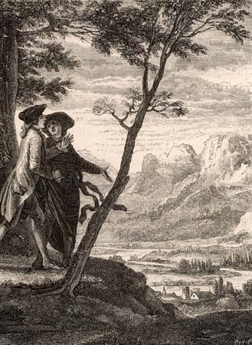

Émile, his major work on education, describes an attempt to educate a simple and pure natural child for life in a world from which social man is estranged. Émile is removed from man’s society to a little society inhabited only by the child and his tutor. Social elements enter the little society through the tutor’s knowledge when the tutor thinks Émile can learn something from them. Rousseau’s aim throughout is to show how a natural education, unlike the artificial and formal education of society, enables Émile to become social, moral, and rational while remaining true to his original nature. Because Émile is educated to be a man, not a priest, a soldier, or an attorney, he will be able to do what is needed in any situation.
The first book of Émile describes the period from birth to learning to speak. The most important thing for the healthy and natural development of the child at this age is that he learn to use his physical powers, especially the sense organs. The teacher must pay special attention to distinguishing between the real needs of the child and his whims and fancies. The second book covers the time from the child’s learning to speak to the age of 12. Games and other forms of amusement should be allowed at this age, and the child should by no means be overtaxed by scholarly instruction at too early an age. The child Émile is to learn through experience, not through words; he is to bow not to the commands of man but to necessities. The third book is devoted to the ages from 12 to 15. This is the time of learning, not from books of course but from the “book of the world.” Émile must gain knowledge in concrete situations provided by his tutor. He learns a trade, among other things. He studies science, not by receiving instruction in its facts but by making the instruments necessary to solve scientific problems of a practical sort. Not until the age of 15, described in the fourth book, does Émile study the history of man and social experience and thus encounter the world of morals and conscience. During this stage Émile is on the threshold of social maturity and the “age of reason.” Finally, he marries and, his education over, tells his tutor that the only chains he knows are those of necessity and that he will thus be free anywhere on earth.
The final book describes the education of Sophie, the girl who marries Émile. In Rousseau’s view, the education of girls was to be similar with regard to naturalness, but it differed because of sexual differences. A girl cannot be educated to be a man. According to Rousseau, a woman should be the centre of the family, a housewife, and a mother. She should strive to please her husband, concern herself more than he with having a good reputation, and be satisfied with a simple religion of the emotions. Because her intellectual education is not of the essence, “her studies must all be on the practical side.”
At the close of Émile, Rousseau cannot assure the reader that Émile and Sophie will be happy when they live apart from the tutor; the outcome of his experiment is in doubt, even in his own mind. Even so, probably no other writer in modern times has inspired as many generations as did Rousseau. His dramatic portrayal of the estrangement of natural man from society jolted and influenced such contemporary thinkers as Immanuel Kant and continues to intrigue philosophers and social scientists. His idea that teachers must see things as children do inspired Pestalozzi and has endured as a much-imitated ideal. Finally, his emphasis on understanding the child’s nature had a profound influence by creating interest in the study of child development, inspiring the work of such psychologists as G. Stanley Hall and Jean Piaget.

