Frankenstein’s Diary/Journal

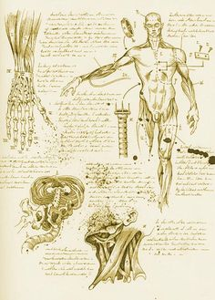
- Students are to create a one-page diary entry from Victor’s point of view immediately following the Creature’s “birth”. Victor’s reactions should be consistent with those we see him experiencing at that moment in the novel. (Ch.5)

- Students are to create a page from Victor Frankenstein’s lab journal during the process of constructing the Creature. Include doodles, random thoughts, etc. (Ch.3-4, this will need at least three direct references from the text.) [See illustration to the right for an example of a lab journal entry.]

